

Identifying Use Cases and Test Cases

Document Guidelines 3

Definitions 3

Activity Diagram 3

Alternative Flow 3

Basic Flow 3

Context Diagram 3

Use Case 3

Use Case Scenario 3

Test Case 4

Naming Convention 4

Assembling the Use Case 4

General Format 4

Basic Flow 4

Alternate Flows 6

Creating Test Cases from Use Cases 9

Identifying Scenarios 9

Documenting the Test Cases 10

Sample Documentation 10

Ensuring Traceability 11

Appendix 11

**Revision History**

|  |  |  |  |
| --- | --- | --- | --- |
| Date | Version | Author | Description |
| 2/25/2015 | 1 | Don Fernando | Draft |
|  |  |  |  |
|  |  |  |  |
|  |  |  |  |

# 

# Document Guidelines

This document proposes a method of deriving functional test cases from use cases for Steelbrick CPQ. Benefits of this approach are:

* Derive test cases in a structured way
* Avoid duplicate testing
* Ensure proper test coverage
* Facilitates monitoring and control of testing progress
* Facilitates work load balancing between testers
* Facilitates regression testing
* Assures validation that build meets requirements
* Contributes to early discovery of missing requirements

# Definitions

## Activity Diagram

An activity diagram is a flow chart that explains the use case.

## Alternative Flow

Alternative flows represent variations of the flow, including less usual cases and error conditions. These are helpful but not mandatory to create a Use Case.

## Basic Flow

The basic flow contains the most popular sequence of actions, the steps that happen when everything goes correctly

## Context Diagram

A context diagram is a part of a use case diagram showing the relationships of this particular use case to actors and other use cases. These are helpful but not mandatory to create a Use Case.

## Naming Convention

Basic Flow: B

Alternative flows: A-001, A-002, A-003, …

Steps in basic flow: B-001, B-002, B-003, …

Steps in alternative flow 1: A-001.1, A-001.2, A-001.3, …

Steps in alternative flow 2: A-002.1, A-002.2, A-002.3, …

## Test Case

A test case represents one set of inputs that exercises a single use case scenario

## Use Case

A use case represents the interactions (or observed behaviors) associated with achieving a goal. A use case tells the story of how someone interacts with a software system to achieve a goal. It will describe multiple paths that the user can follow within the use case

## Use Case Scenario

A use case scenario represents one of the possible paths through a use case.

A use case is made up of one or more use case scenarios. Each path that can be followed within the use case is a use case scenario. Any given example of following a use case also follows a single scenario. Multiple executions of the use case can use the same or different scenarios.

# Assembling the Use Case

## General Format

Assembling the use case starts by identifying the basic flow. Once the Basic flow is documented there will inevitably be multiple variations to it, each of which become Alternate flows. The Basic flow will help to also establish special requirements, preconditions, post-conditions, extension points, Context diagrams, and Activity diagrams. Here is the general format of a use case:

1. Brief description
2. Flow of events
   1. Basic flow
   2. Alternative flow 1
   3. Alternative flow 2
3. Special requirements (Business Rules/Logic)
4. Preconditions
5. Post-conditions
6. Context diagram
7. Activity diagram

## Basic Flow

For example, in SteelBrick to create a new quote as a basic flow could be characterized as:

|  |  |  |  |
| --- | --- | --- | --- |
| UC-001 Create New Quote | | | |
| *Flow* | *Flow Description* | *Triggers* | *Outcome* |
| B-001 | Create new opportunity and quote | Sales rep selects account and clicks ‘Create Opportunity. Sales rep clicks ‘New Quote’ and enters start date and term | SFDC returns empty Quote Page |
| B-002 | Configure bundle | Sales Rep clicks ‘Edit Lines’, presented SB Quote (header only), fills in term and start date, clicks ‘Add Products’ to enter Config page. Choose product options | SB configuration page with appropriate product options selected |
| B-003 | Price line items on quote | After products are chosen in config the user clicks ‘Save’ SB Quote Products Page (Line Editor) is presented with Regular Price | SB Line Editor displays correct List, Regular Price, Net Price |
| B-004 | Generate quote output | User on the SB quote with quote lines present clicks “Preview Document” | Quote template rendered |

This basic flow will yield this Activity Diagram:

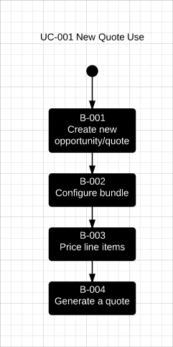

The Basic flow will also yield this Context Diagram:

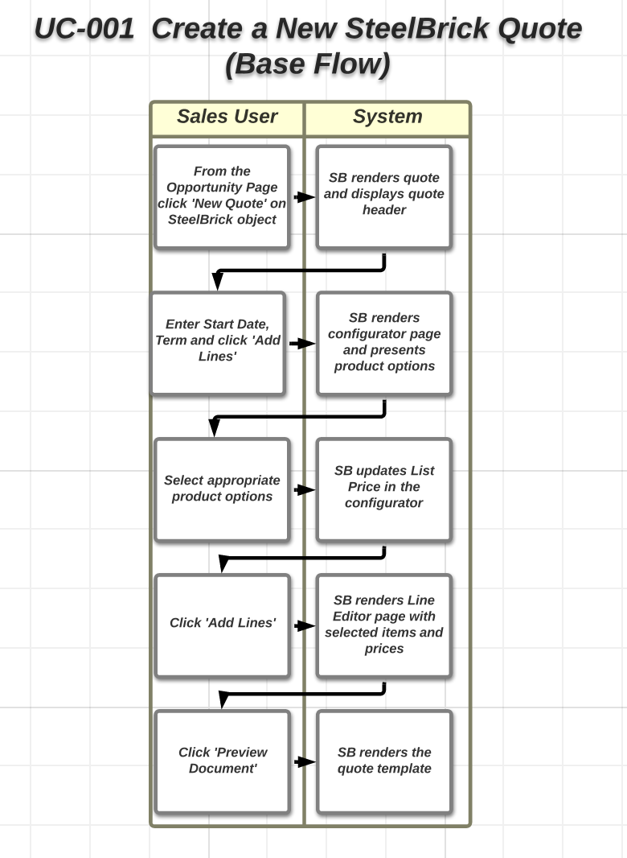

## Alternate Flows

Now that the basic flow is documented, alternate flows can be added to it. For example, and alternate flow for “B-002 Configure bundle” could be “A-001 Select products”. Another example could be adding a new flow such as “A-002 Apply quote level discount”. Some alternate flows may lead to more. For instance, for approvals it may be helpful to create “A-003 Submit for approvals”, “A-004 Approve approvals request”, and “A-005 Reject approvals request”

|  |  |  |  |
| --- | --- | --- | --- |
| Alternative flows for UC-001 | | | |
| *Flow* | *Flow Description* | *Triggers* | *Outcome* |
| A-001 | Select Products | Sales Rep clicks ‘Edit Lines’, presented SB Quote (header only), fills in term and start date, clicks ‘Add Products’ to enter Config page. User uses search to filter selectable products | SB configuration page with appropriate product options selected |
| A-002 | Apply Discounts | User on the SB Quote Products Page (Line Editor) will enter a value for the discount field on the quote level and clicks ‘Calculate’ | SB Line Editor calculates discount and displays correct List, Regular Price, Net Price |
| A-003 | Submit for Approvals | User on the Quote Page clicks ‘Submit for Approval’ | SB Quote read only to Sales Rep. Email notifications sent to approvers  Quote status changed to ‘Pending’ |
| A-004 | Approve request | Approver receives email for approval request and approves. | SB Quote made editable and approval notification sent to Sales Rep.  Sales Rep has the ability to generate quote output.  Quote status changed to ‘Approved’. |
| A-005 | Reject request | Approver receives email for approval request and Rejects. | SB Quote made editable and recjection notification sent to Sales Rep.  Quote status changed to ‘Rejected’. |

With the addition of these Alternate flows the Activity Diagram will look like:

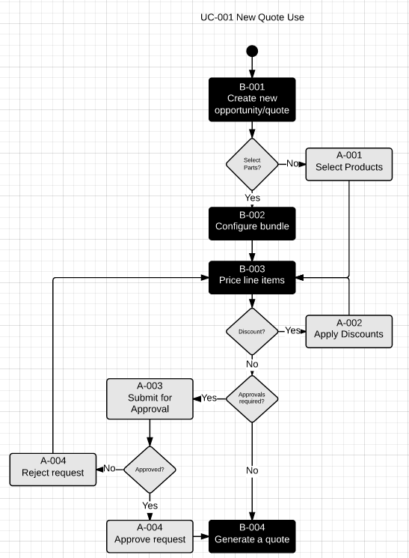

# Creating Test Cases from Use Cases

## Identifying Scenarios

Creating the Activity diagram is helpful in identifying all scenarios for the given use case. A use case scenario is an instance of the use case describing on specific path along the way. For example, the basic flow scenario can be illustrated as:

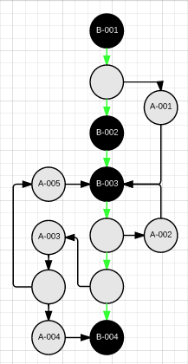

Base Flow

Alternate scenarios can be illustrated as:

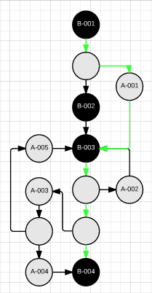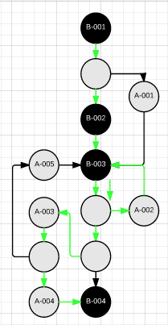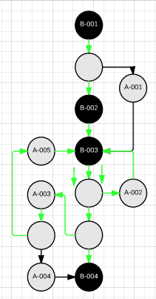

|  |  |  |
| --- | --- | --- |
| Select Products | Discounts Applied, Request Approved | Discounts Applied, Request Rejected |

Some scenarios may be deemed more critical than others. The determination of what is critical should be a joint decision between end users and technical resources.

The easiest way to describe the steps of a scenario is to provide the sequence of alternative flows. The summary of scenarios, or test cases, worth testing can then be produced:

|  |  |  |
| --- | --- | --- |
| Test Case | Description | Path |
| 1 | Base Flow | B |
| 2 | Select Products | A-001 |
| 3 | Discounts Applied, Request Approved | A-002, A-003, A-004 |
| 4 | Discounts Applied, Request Rejected | A-002, A-003, A-005 |

Another way to describe the paths is to provide a sequence is to list all steps but this may become cumbersome and unnecessarily detailed.

When loops are in effect, like approval test case 3 and 4, it could theoretically generate an infinite number of scenarios. A reasonable approach is to do the basic flow once, do a loop once, then do a loop a second time. If the functionality works for both instances of the loop then it is within reason to assume it will work for all loops.

# Documenting the Test Scripts

A test script should outline steps necessary to test that the system functions as expected. Each step will have the basic information associated to it:

|  |  |
| --- | --- |
| Step | Outlines the order of execution.  Basic Flow: B  Alternative flows: A-001, A-002, A-003, …  Steps in basic flow: B-001, B-002, B-003, …  Steps in alternative flow 1: A-001.1, A-001.2, A-001.3, …  Steps in alternative flow 2: A-002.1, A-002.2, A-002.3, … |
| Object | Identifies the SFDC or SteelBrick object to perform action or validate information on |
| Action | Action the test user will be performing. It may involve an actual click of a button or validating certain information |
| Entered Value | Identifies specific values or selection to form fields |
| Expected Result | Outlines how the system should behave after performing an action |
| Actual Result | Outlines how the system reacted after performing an action |
| Business Rule | Identifies any business logic than needs to be manifested at a certain point of the test script |
| Status | Can be Pass/Fail/In Progress |
| Defect # | Associates a Failed step in a test script to a defect tracking mechanism |

## Sample Documentation

# Appendix

1. Sales Rep creates and Opportunity – selects Account and enters Opportunity Name
   1. SFDC returns Opportunity page
2. Sales Rep creates a quote – clicks new Quote and enters Start Date and Term
   1. SteelBrick returns Quote Page
3. Sales Rep configures a product and adds to the quote – Sales Rep clicks ‘Add Lines’ and configures product
   1. SteelBrick returns Quote Page with line items and correct pricing
4. Sales Rep discounts pricing – Sales Rep clicks ‘Edit Lines’ and enters a discount value (either on quote header, bundle line or item line”)and clicks ‘Calculate
   1. Steelbrick returns line item page with discounts applied
5. Sales Rep sends quote for approval – from the Quote Page the Sales Rep clicks ‘Submit for Approval’
   1. SFDC will send email notifications to approvers
   2. SFDC will return the Quote page in a read only view until Approved
   3. When the Approver approves the request the Sales rep view of Quote becomes editable and Approval Status changes to ‘Approved’
6. Sales Rep generated quote template – from the Quote Page the Sales Rep clicks ‘Preview Document’
   1. Steelbrick will return the Quote Template
7. Sales Rep close/wins the deal – Sales Rep changes Opportunity Stage to ‘Closed – Won’
   1. SFDC will return the opportunity page with Stage updated

Basic flows to consider are:

|  |  |
| --- | --- |
| B-001 | Create a New Quote |
| B-002 | Contract Creation |
| B-003 | Create a Renewal Opportunity |
| B-004 | Create a Renewal Quote |
| B-005 | Create an Add-on Quote |
| B-006 | Create an Upgrade Quote |
| B-007 | Submit for Approvals |
| B-008 |  |
| B-009 |  |
| B-010 |  |